**JSON response has numeric elements - what if they send null values**

**SCENARIO: we have a Service we are getting JSON response has a numeric elements and what if they send null values and id increases elements after creating service how can we handle.**

**ACTIVITIES: 1.REST Service ( GET operation)**

**2.Invoke RESTAPI**

**3.Parse JSON**

**4.Timer**

**Invoke RESTAPI:**

**Invoke REST API asynchronous activity invokes Restful web services and receives responses from the service provider.**

**Parse JSON:**

**Parse JSON activity takes the JSON data, processes it, and converts it into XML data**.

**TIMER:**

**Timer is a process starter activity that starts the process at a specific time. You can also specify the processes to be started periodically.**

**USED X-PATH FUNCTIONS:**

**TOKENIZE:**

**Tokenization is breaking the raw text into small chunks. Tokenization breaks the raw text into words, sentences called tokens. These tokens help in understanding the context. The tokenization helps in interpreting the meaning of the text by analyzing the sequence of the words.**

**CONTAINS:**

**CONTAINS is a string manipulation function that manipulates all string data types, and returns a Boolean value to indicate whether one string is present within another.**

**PROCEDURE:**

**1. Open Tibco Business Studio and create a new BW Project.**

**2. Create a new module within the project.**

**3. Right-click on the module and select "New -> REST**

**Service" from the menu.**

1. **In Resource folder create one Http resouce and mention host and port numbers and configre with bindings**

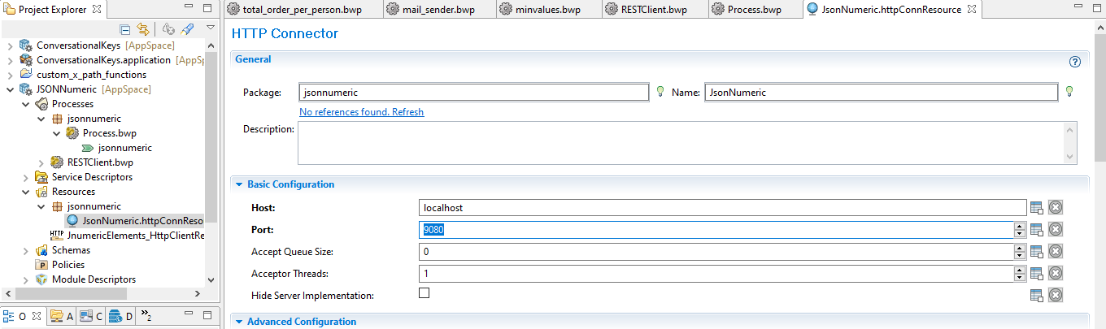

1. **Select the Get operation and click on check give the schema in input parametres or in input editor.**

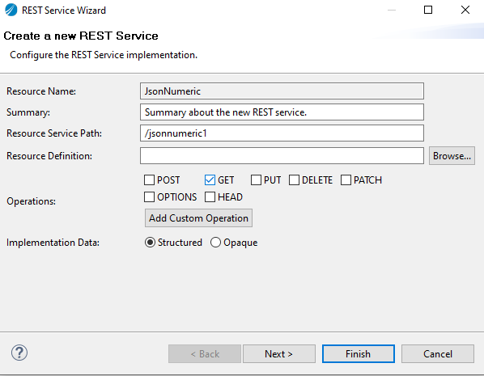

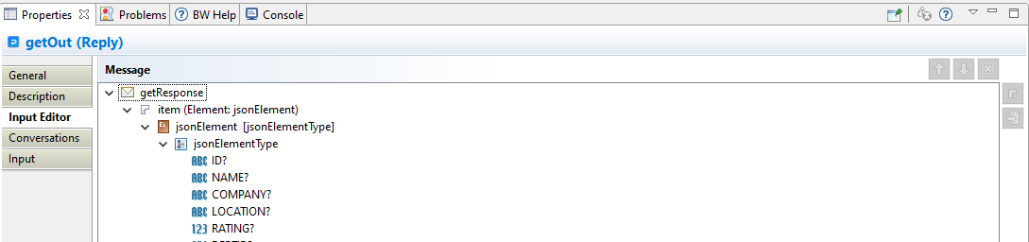

1. **next givethe values in input.(we are mentioned values as literal map the output elements in input as get operation as per your requirement.**

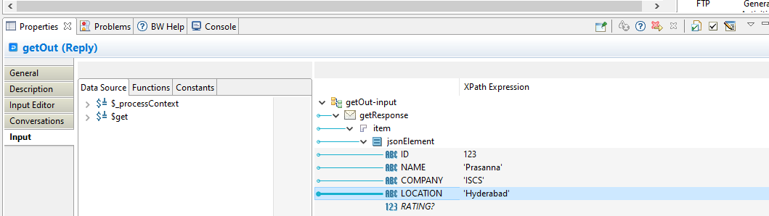

1. **Create one rest client as below and mentioned the same host and port number as per out http resource we are taken in rest service.**

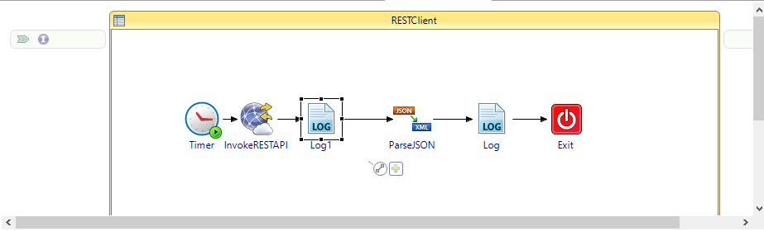

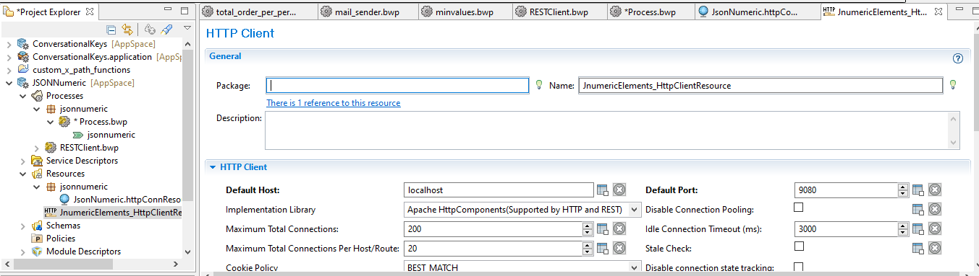

1. **If some elements we need to add in rest service we can give the element in input editor tab of rest service and give the values in input tab .**
2. **In parseJson take GENERIC in schema type andmap in to input tab.**

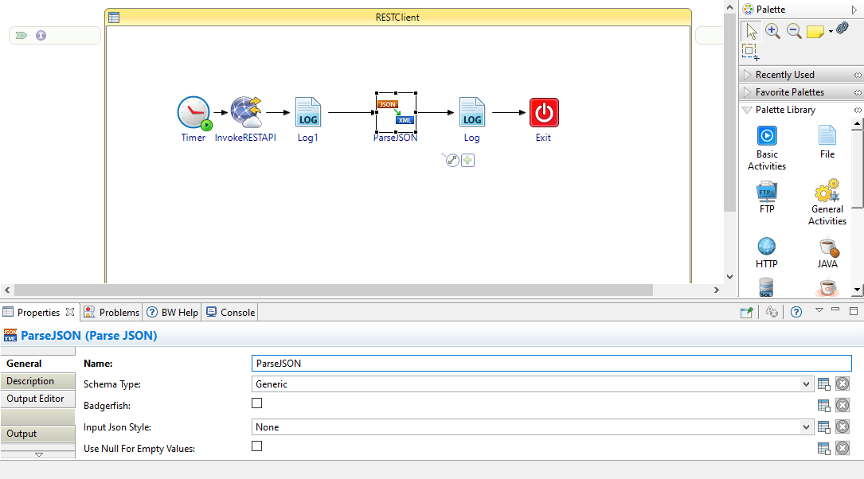

**10.create variables as per requirements with tokenize function as mentioned below we are created two variables in this scenario for variable (var) is for if rating is not null and second variable (var1) is for if rating elemnts is null.**

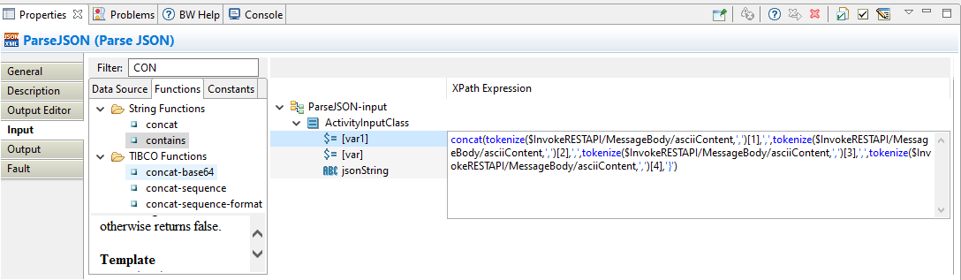

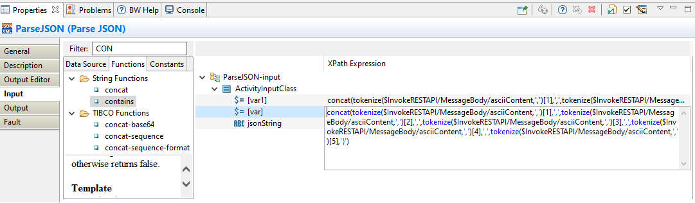

**11.Write if then else combination function in the jesson string, if rating is CONTAINS and not null then we get variable and other wise we can get variable1.**

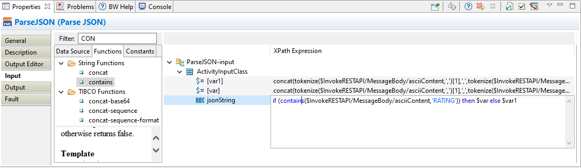

1. **DEBUG The application.**

**Case1:- if Rating element is not null and passing the value.**

**Then output is {"ID":"123","NAME":"Prasanna","COMPANY":"ISCS","LOCATION":"Hyderabad","RATING":5,"DEPTID":"25"} we can see in invoke RESTAPI output.**

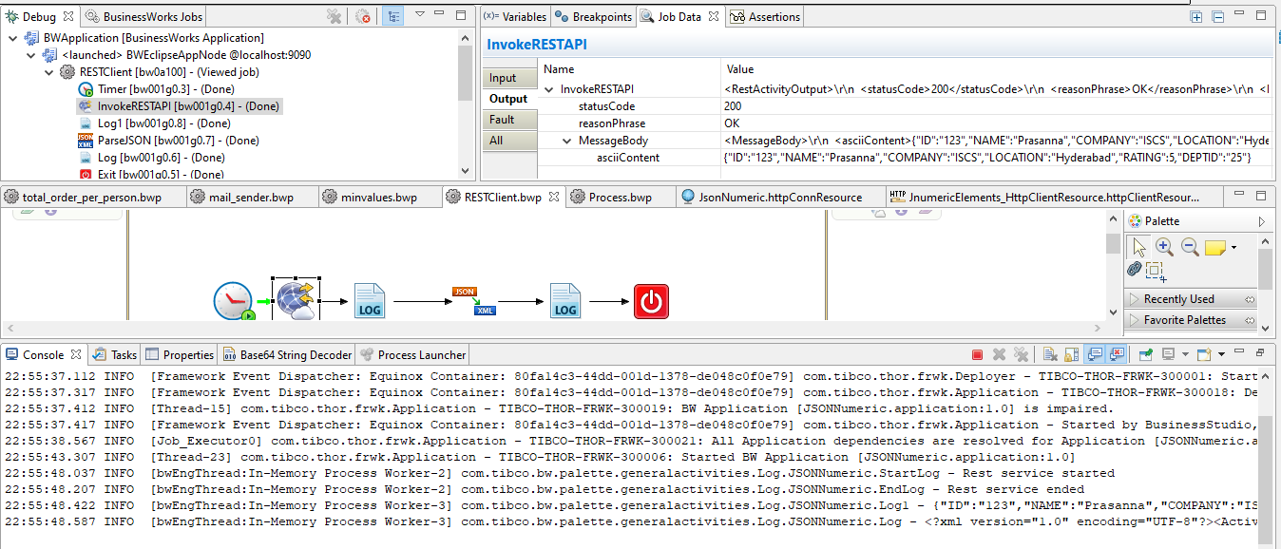

**Case2:- if Rating element is null and passing the value.**

**Then output is {"ID":"123","NAME":"Prasanna","COMPANY":"ISCS","LOCATION":"Hyderabad","DEPTID":"25"} we can see in invoke RESTAPI output.**

